Details for Contact Us Page of your Catalog (from where buyer can send enquiries). Along with this you can also send Contact details for Branch Office and Manufacturing Unit.
*Company Name  To be displayed as It is on Website  ( Write with correct spacing, character style and Spelling) |  | IMPARADISE FOOTWEAR
*Contact Person |  | Deepanker Agarwal
Designation of Contact Person |  | MD
*Street Address |  | 9/99 Yamuna Bridge, Station Road
*City |  | Agra
*State |  | Uttar Pradesh
*Country |  | India
*Postal Code |  | 282006
*LandLine Phone(s)
*Whatsapp No. |  | +91-9760410684
*Mobile Phone |  | +91-7055102684
Reliance Phone (if any) |  | No.
Logo |  |  | 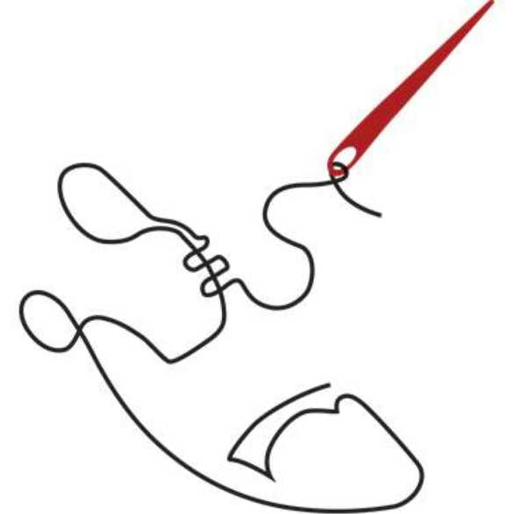
Design ID (Please mention ID of Selected Template) Template number once confirmed is taken as final.
Remarks (If any) |  |  | Kindly Display my Company Brand name as Imparadise as moving on website
* Nature of Business with Products/Services Names (fill minimum one column)
We Manufacture |  | Genuine Leather Footwear in Men category
We Export |  | Genuine Leather Footwear in Men category
We Import |  | Leather
We Supply |  | Driving Shoes, Loafers, Formals, Sandals, Filp Flops, Casuals Shoes, Party Wear Shoes
We provide services for
* Products to be mentioned in website *
*Main Products/ Service (In priority order) |  | - Loafers  - Fromals  - Brogue  - Sandals  - Safety shoes  - Boots  - Slippers  - Casuals Shoes
USP of your Products/ Service (Any feature on what you claim that your products are best.) |  | - Genuine Leather Material,  - Best Quality PU & TPR Sole,  - Injection molding Safety Shoes.  - No compromise in any condition for quality
*Keywords  ( If you want to provide Keywords please mention here. You can provide keywords only once, before designing. After designing, any changes in keywords would be done only on paid basis. ) |  | - Footwear  - Sandals & Slippers  - Casual & Sports Sandals  - Shoes  - Leather Shoes  - Formals Shoes  - Loafer
About Office
*Establishment Year |  | 2014
*Name of Owner/CEO |  | Mr. Deepanker Agarwal/Mr. Harshit Agarwal
Experience |  | 1yr.
Qualification or Specialization |  | Mr. Deepanker Agarwal(MD)  - MBA(In Marketing) From ISBE(International School of Business Education), New Delhi.  - B.com from St. jhons College, Agra  Mr. Harshit Agarwal (CEO)  - Diploma In Shoe Designing & Manufacturing from CFTI, Agra  - B.com From RBS College, Agra
Number of Employees |  | 18
Turnover |  | 50Lc Quaterly
Quality Certification
Achievement and Awards
*About Us (A brief introduction of your company) |  | We have a Leather Footwear manufacturing unit based in Agra(UP) -well known for its Footwear.  The company was incorporated by Deepanker Agarwal in the year 2014 starting with 4 Designs of Leather Slippers, we have come a long way....  ABOUT US  CORPORATE PROFILE:  Mr Deepanker Agarwal & Mr Harshit Agarwal the Founders of the company, having exceptional business Ideas in product development and long years of marketing experience, is a well-known personality in the leather world. They always tries to give best products to their customers. They are known for his hard work, dedication and persistence.  - Imparadise Footwear India's first premium genuine leather shoes  - It's a export company, crafted from high end leather  - Imparadise Footwear gives International quality with latest style products to Indian market with affordable price  - Imparadise Footwear supplies in wholesale all over India.  - We gives you Real high end leather shoes  - Formals, casuals, boots, ankel boots, loafers, party, wedding shoes & Safety Shoes  ABOUT THE COMPANY:  Imparadise Footwear a brand created by young, experienced and enthusiastic fashion professionals, Imparadise Footwear brings International trends of fashion from all over world to India.  - Our versatile range is a combination of style and ethncity  - Offered in a variety of attractive designs and patterns and styles  - Our product define new standards of quality and panache across India. We present the splendid assortment of shoes to cater to varied taste and preferences Gen Next.  Philosophy  We strive for exellence in every thing we think, say, and do.  1. Collaboration & team work  2. Innovation & continue learning.  3. Quality  OUR VISION:  We aim to bring high quality products at very moderate prices to India's youth and make their dream 'affordable fashion wear' come true.  We provide International Quality, International Style and International Design with affordable price.  IMPARADISE FOOTWEAR represents a sophisticated brand of luxury men’s footwear which never loses sight of the real art of handcrafting and enhances the personality of those experiencing the brand. IMPARADISE FOOTWEAR prides itself on manufacturing some of the highest quality men's shoes in the market.  The value of the shoes has always been a factor of gratitude for IMPARADISE FOOTWEAR brand. In order to satisfy this objective, we select the raw materials with special attention. IMPARADISE FOOTWEAR has managed to customize tailor-made designs that suit the customer of all ages.  IMPARADISE FOOTWEAR creations are all made strictly by hand in a factory, in limited numbers with complete research into leathers, materials and details.
*About Factory or Manufacturing Unit (only for manufacturers)
Area |  | 3800sqfts.
Machinery |  | 12 all hitech
Production Capacity |  | 5000 pairs per month
Raw Material Used |  | Leather & Best Quality Soles
Customized Production Facility |  | Available as per our terms & Conditions
Testing Facilities
R&D Facilities
How many Factories you have? |  | 1
USP of your working
About Operations
*Countries you deal in |  | India & overseas also
*Industries where you want to sell your products/Services |  | Tata, Reliance, Wipro & other highly repudiated Companies
Clientele (Mention names of your clients)
Packaging Material |  | Box & other required material
Customized Packaging Facility |  | Available on our Terms & Condition Basis
CAD (Computer-Aided Design)/CAM (Computer-Aided Manufacturing)Facility |  | CAD
Any Other Information
*Minimum order Quantity |  | 100pairs
*Price of your products |  | Depend & varies on quality & products
*Customization on products if required by your clients .Yes/No |  | Yes

